

Dos Columnas Css

Alumno | Carlos Daniel Garfio Murillo
Matricula | 1117150109
Materia | Desarrollo De Aplicaciones Web
Maestro | M.G.T.I. Blanca Estela Chavarria Salinas
Fecha | 26 de octubre de 2021
Grupo | ITI91N

Index.html
<!DOCTYPE html>
<html lang="en">
<head>
<meta charset="UTF-8" />
<meta http-equiv="X-UA-Compatible" content="IE=edge" />
<meta name="viewport" content="width=device-width, initial-scale=1.0" />
<title>Ejercico 7</title>

<link rel="stylesheet" href="./css/estilos.css" />
</head>
<body>
<div class="contenedor dos-columnas">
<article class="articulo">
<h1>Titulo Imagen</h1>
<img src="https://via.placeholder.com/500" alt="" srcset="" />
<p>
Lorem ipsum dolor sit amet consectetur adipisicing elit. In,
distinctio alias beatae recusandae debitis ducimus dolor eius
laudantium officiis necessitatibus quos dicta eveniet eligendi libero,
commodi quam sint aliquid ratione.
</p>
<a href="#">Leer mas...</a>
</article>
<article class="articulo">
<h1>Titulo Imagen</h1>
<img src="https://via.placeholder.com/500" alt="" srcset="" />
<p>
Lorem ipsum dolor sit amet consectetur adipisicing elit. In,
distinctio alias beatae recusandae debitis ducimus dolor eius
laudantium officiis necessitatibus quos dicta eveniet eligendi libero,
commodi quam sint aliquid ratione.
</p>
<a href="#">Leer mas...</a>
</article>
</div>
</body>
</html>

CSS
@import url("https://fonts.googleapis.com/css2?family=Poppins:wght@400;700&display=swap");

*,
*::before,
*::after {
box-sizing: border-box;
margin: 0;
padding: 0;
}

body {
font-family: Poppins, sans-serif;
font-weight: 500;
}

img {
max-width: 100%;
}

h1 {
font-size: 4rem;
}

.contenedor {
max-width: 1200px;
width: 95%;
margin: 0 auto;
}

.dos-columnas {
display: grid;
}

.articulo {
display: inline-block;
background-color: #9cb3ca;
color: #ffffff;
padding: 10px 20px;
text-decoration: none;
font-weight: bold;
text-transform: uppercase;
}

/* Extra small devices (phones, 600px and down) */
@media only screen and (max-width: 600px) {
.dos-columnas {
column-gap: 0.75rem;
row-gap: 0.75rem;
grid-template-columns: 1fr;
}
}

/* Small devices (portrait tablets and large phones, 600px and up) */
@media only screen and (min-width: 600px) {
.dos-columnas {
column-gap: 0.75rem;
row-gap: 0.75rem;
grid-template-columns: repeat(2, 1fr);
}
}

/* Medium devices (landscape tablets, 768px and up) */
@media only screen and (min-width: 768px) {
}

/* Large devices (laptops/desktops, 992px and up) */
@media only screen and (min-width: 992px) {
}

/* Extra large devices (large laptops and desktops, 1200px and up) */
@media only screen and (min-width: 1200px) {
}

Resultados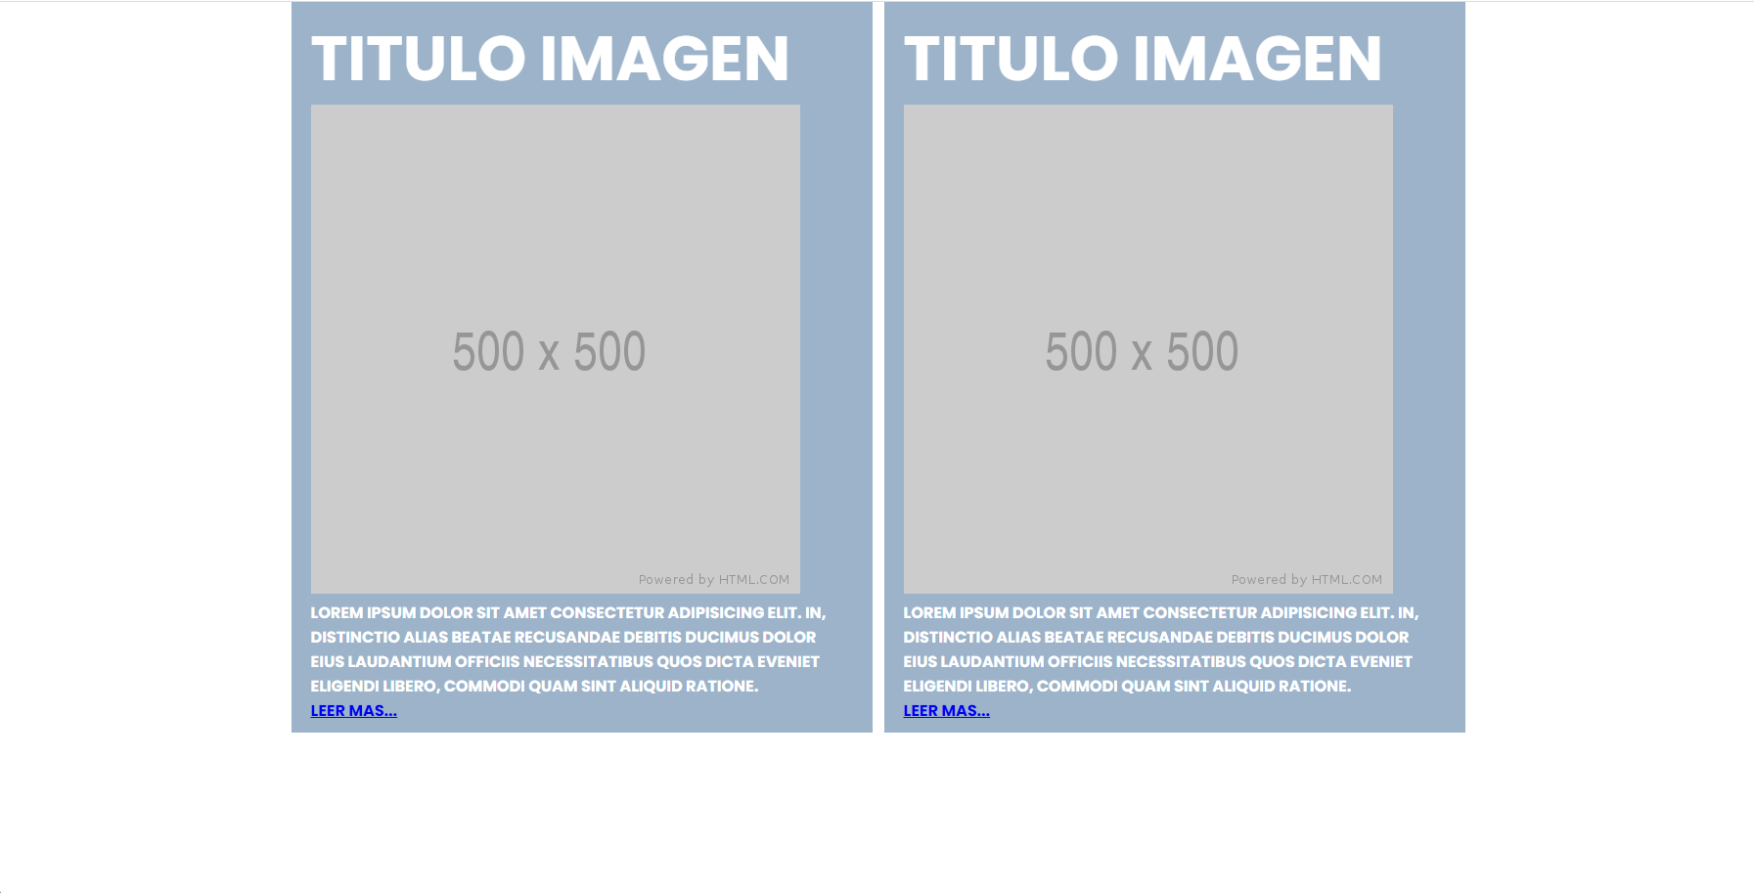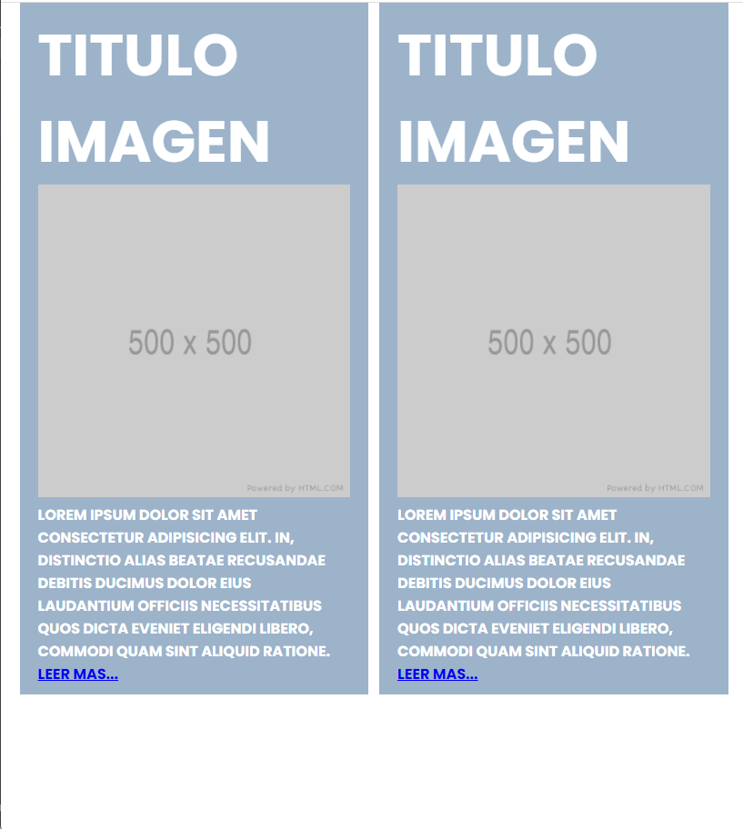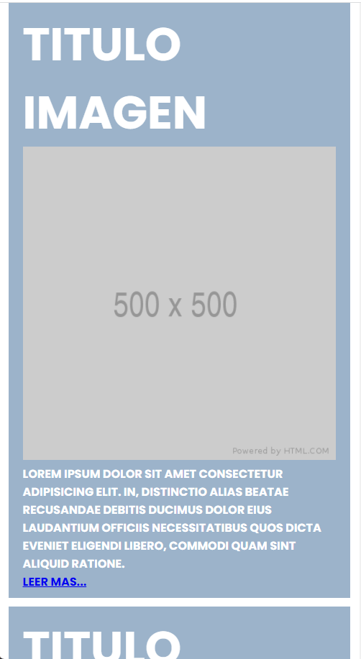
Codigo Fuente
https://github.com/CarlosGarfio/Desarrollo-de-Aplicaciones-Web

